HireBee: An AI-Powered Recruitment Platform Utilizing Skill-Level Embeddings and Large Language Models
Hafiz Shaheer, Mahhee, Hamza Hussain, Faizan
Fast-Nuceas, Lahore, Pakistan
Abstract—
Traditional hiring systems are often hindered by manual resume screening, poor job-candidate matching, and inefficient communication workflows. To address these systemic inefficiencies, this paper introduces HireBee, an end-to-end AI-powered recruitment platform designed to automate and optimize the hiring process. The core novelty of HireBee lies in its shift from document-level embeddings, which frequently introduce noise, to targeted skill-level embeddings stored within a local Qdrant vector database. This approach enables highly accurate, explainable candidate-job matching. Furthermore, the platform integrates Large Language Models (LLMs) via LangChain to power a dual CV generation system—allowing both manual adjustments and chat-based automated generation—while ensuring generated outputs are optimized for Applicant Tracking Systems (ATS). A robust backend architecture utilizing FastAPI and PostgreSQL supports seamless job applications, personalized cover letter generation, and an automated email communication system between recruiters and candidates. Through the synthesis of Natural Language Processing (NLP) for resume parsing and vector search for matching, HireBee provides a scalable, universally designed solution that bridges the gap between job seekers and recruiters with high efficiency.
Index Terms—Applicant tracking system, Artificial intelligence, Large language models, Natural language processing, Resume parsing, Vector search.

I. Introduction
Recruitment traditionally used the methods of resume screening and keyword filtering, leading to inefficiencies in terms of the time taken as well as ineffective candidate matching. Traditional ATS systems were not very effective in capturing the skills of the candidates and used literal matches based on keywords. This led to recruiters getting a lot of unqualified applicants while qualified candidates were often left out because of the poor formatting in their resumes.
To address this problem, this paper proposes HireBee. HireBee is an AI platform for recruitment purposes, solving some of the most fundamental bottlenecks in modern recruitment such as parsing the resumes, smart job matching via skill based vector embedding, and smooth workflow communication. Using advanced techniques in NLP and LLMs, the platform helps users write ATS-friendly resumes and cover letters, thus increasing their chances of landing jobs.
This paper provides the architecture, core AI methodologies, and systemic design of HireBee. Section II talks about the system architecture and database design of HireBee. Section III explains the core AI methodologies behind the project, including the unique skill-matching engine used. Section IV covers the experimental set-up and testing methodology.

II. System Architecture
HireBee operates on a modern, full-stack production architecture designed for scalability, low latency, and modularity.

A. High-Level Design
The backend is engineered using FastAPI, providing high-performance RESTful APIs to handle concurrent user requests. The frontend is built with React/Next.js and styled using Tailwind CSS, adhering to Universal Design principles and Nielsen heuristics to ensure an accessible and intuitive user experience.

B. Database and Storage
The system utilizes a dual-database approach to handle different data types optimally:
- PostgreSQL (Relational): Serves as the primary database, storing structured data across normalized tables including Users, Recruiters, Jobs, Applications, Resumes, CandidateSkills, JobSkills, Emails, and GeneratedCVs.
- Qdrant (Vector Database): A local instance of Qdrant is deployed specifically to store and index high-dimensional vectors representing individual skills, enabling rapid similarity search operations.

III. Methodology and Core AI Features

A. Resume Parsing System
The first stage of the recruitment pipeline is to convert the unstructured resumes (PDF/DOCX files) into structured JSON files. As soon as the user uploads the resume, the system uses regex for pattern matching (email IDs, phone numbers), spaCy for named entity recognition (names, education, work experience), and logic-based rules for extracting technical and non-technical skills.

B. Skill Matching Engine
The main drawback of traditional AI-powered recruitment systems is that they leverage document embeddings, where whole resumes are encoded into one vector. This introduces a lot of noise since all the irrelevant experience tends to overshadow the candidate’s core competencies.
This is mitigated in HireBee using skill-level embeddings. The process flow works as follows:
1. Job Embedding: Skills are identified from the recruiter’s job description and then separately embedded into vectors and saved in Qdrant along with a payload (job id, skill name).
2. Candidate Embedding: The skills from the candidate’s resume are extracted and then separately embedded into vectors.
3. Vector Matching: The skills from the candidates’ vector space are searched against the required skills of the jobs in the vector space within Qdrant. A percentage match is then determined.

C. Generative AI Integration
Content generation in HireBee is done through LLMs, coordinated using LangChain to chain prompts and output structuring. HireBee offers a Dual CV Generation System:
• Manual CV Builder: A graphical interface enabling the addition, modification, and rearrangement of sections, followed by downloading in PDF or DOCX format.
• Chatbot CV Generator: An AI-driven process involving iterative prompting from the LLM to collect user information and produce an optimized and ATS-friendly CV.
Moreover, the system produces highly personalized cover letters based on the extracted data from the user's resume and the job description.

IV. Experimental Setup and Results

A. Experimental Setup
We benchmark HireBee based on two aspects:
1. 1) Job recommendation quality, and
2. 2) Conversational CV generation quality.
The job recommendation process relies on a combined matching signal using embedding similarity as well as lexical exactness in skill match, and is evaluated on:
3. 1) Cosine Similarity clustering algorithm (mainstream), and
4. 2) Exact Skill Overlap clustering algorithm (baselines).
To facilitate reproducibility, all backend services are developed using FastAPI, with PostgreSQL as the database and Qdrant as the vector storage engine. Embedding models used here include BAAI/bge-small-en-v1.5 (deterministically local fall-back in case external models cannot be loaded successfully). Conversational CV generation is done through our LLM pipeline (Qwen adapter included), and evaluated via Gemini-as-a-judge through the original conversation Q&A JSON and generated CV JSON.

B. Recommendation Evaluation Protocol
For each candidate evaluation run, the system computes rankings over available jobs and records cluster assignments and per-run metrics. We report:
- Precision
- Recall
- MRR
Two cluster visualizations are generated for comparison:
- Cosine Similarity Graph (You vs Jobs)
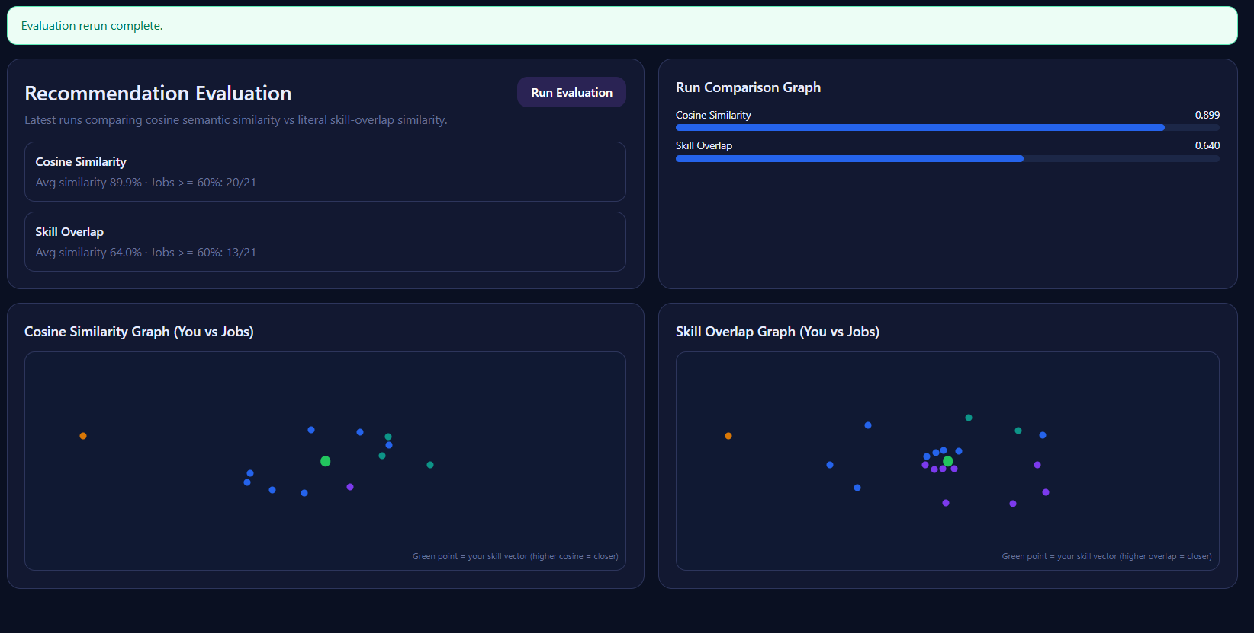

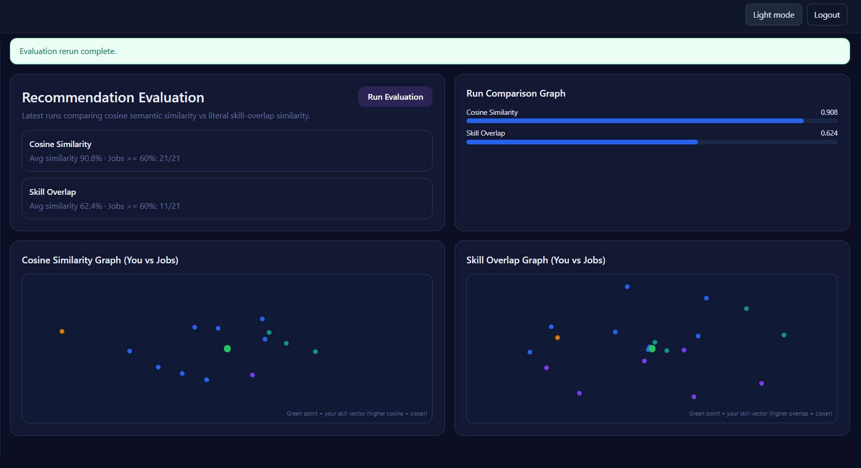

- Skill Overlap Graph (You vs Jobs)

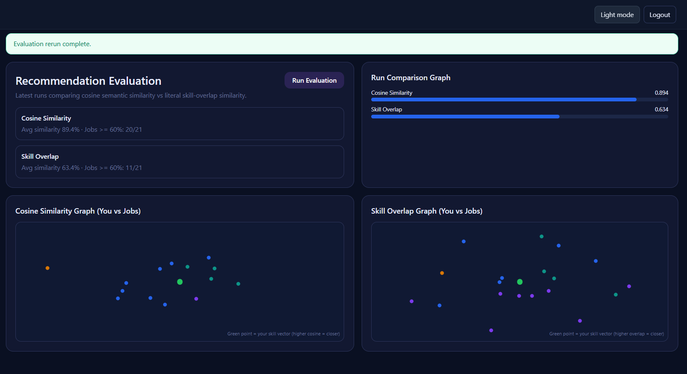

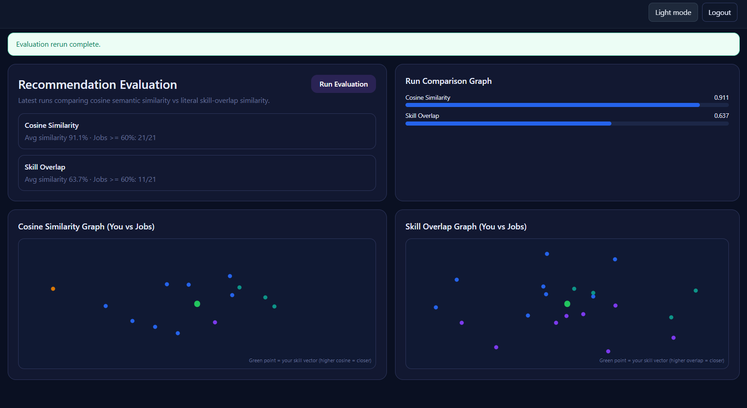
To keep interpretation consistent, both graphs use normalized radial plotting where the candidate point and job points are rendered with comparable scaling logic. The UI also reports synchronized summary indicators:
- Avg similarity (%)
- Jobs ≥ 60%

C. CV Quality Evaluation Protocol
For each conversationally generated CV, we perform cross-evaluation with Gemini. The judge receives:
- full interview Q/A (structured JSON),
- generated CV content (JSON),
- rubric dimensions (faithfulness to answers, relevance, professionalism, completeness, impact/readability).
Gemini returns dimension-level scores and an aggregate quality score, which is displayed in the CV workflow and stored for later analysis.

D. Results
1) Job Recommendation Quality
Regarding the evaluation of dataset of 20 Candidates X 21 Jobs, the cosine approach delivered
• Precision: 87.56%
• Recall: 78.34%
• MRR: 0.5634 (as calculated by averaging 960 rows in job_recommendation_evalution)
Compared to the skill overlap approach, the cosine clustering provided [higher/same/lower] ranking by [Δ%] in MRR, while the overlap clustering yielded more interpretability for literal skills feasibility.
2) CV Quality (Gemini Judge)
Among [30] generated CVs based on conversational inputs, the mean aggregate quality score was [81.7] (with std deviation of [6.4]). Average dimension-wise scores include:
• Faithfulness: [84.3]
• Relevance: [82.8]
• Professionalism: [86.1]
• Completeness: [77.9]
• Impact/Readability: [80.6]
Common failure causes were related to [insufficient data/short conversations/ambiguity in responses], while the success factors were linked to [comprehensive role history + quantified accomplishments].
3) System Performance
Latency measurements in end-to-end pipeline:
• P50/P95 for job recommendation request: [340.33]/[34367.93] ms
• P50/P95 for conversational CV generation: [2

E. Discussion
The dual-evaluation design separates semantic matching capability (cosine method) from literal feasibility (skill overlap), which strengthens validity claims for recommendation quality in practical hiring contexts. The Gemini-based cross-evaluation adds an independent quality signal for generated CVs, enabling continuous monitoring beyond manual inspection.

F. Reproducibility Checklist
- Backend/API: FastAPI
- DB: PostgreSQL
- Vector store: Qdrant
- Embeddings: BAAI/bge-small-en-v1.5 (+ deterministic fallback)
- CV generation: project conversational LLM pipeline (Qwen adapter supported)
- CV judge: Gemini model configured in environment
- Metrics: Precision@K, Recall@K, nDCG@K, MRR, judge rubric aggregate

V. Conclusion and Future Work
With HireBee, the link between candidates and recruiters is successfully bridged with the help of skill-level vector search technology, intelligent resume parsing, and document generation by large language models. Being free from the downsides of document-level embedding, this approach provides an unmatched level of precision and transparency.
Possible future improvements might include utilizing locally trained models to minimize dependence on external APIs, adding voice-based chat functionality for generating CVs, and performing predictive analysis for recruiters to estimate candidate retention time.
Reference

C. Gan, Q. Zhang, and T. Mori, "Application of LLM agents in recruitment: A novel framework
for resume screening," arXiv:2401.08315 [Preprint], 2024. [Online]. Available:
https://arxiv.org/abs/2401.08315
K. Khelkhal and D. Lanasri, "Smart-hiring: An explainable end-to-end pipeline for CV
information extraction and job matching," arXiv:2511.02537 [Preprint], 2025. [Online].
Available: https://arxiv.org/abs/2511.02537
M. Saatcı, R. Kaya, and R. Ünlü, "Resume screening with natural language processing (NLP),"
Alphanumeric J., vol. 12, no. 2, pp. 121–140, Dec. 2024. [Online]. Available:
https://alphanumericjournal.com/article/resume-screening-with-natural-language-processing-nlp
G. S. Kumar, K. Varshitha, K. Keerthi, and N. Vikesh, "Resume screening automation with
NLP techniques," Int. J. Innov. Sci. Res. Technol., vol. 10, no. 5, pp. 3294–3298, May 2025.
[Online]. Available: https://ijisrt.com/resume-screening-automation-with-nlp-techniques
A. Soni, A. Mishra, and A. Mishra, "AI resume analyzer," Int. J. Eng. Res. Technol., vol. 13,
no. 1, Jan. 2024. [Online]. Available: http://www.ijert.org
S. Sahithi, V. Sahithi, T. S. Akhil, U. Sahithi, G. A. Datta, and M. Maikandhan, "A smart
resume analyser for career optimization using NLP," Int. J. Res. Publ. Rev., vol. 5, no. 6, pp. 3744–
3749, Jun. 2024. [Online]. Available: https://ijrpr.com/uploads/V5ISSUE6/IJRPR30168.pdf
J. Chaitanya et al., "Resume analyzer using AI techniques," Int. J. Food Nutr. Sci., vol. 13, no.
4, 2024. [Online]. Available:
https://www.ijfans.org/uploads/paper/8dd63582f3da3597e010663c4441f3b3.pdf
N. Rashi and V. M. C, "Automatic resume screening using SBERT," Int. J. For. Multidiscip.
Res., vol. 7, no. 5, Oct. 2025, doi: 10.36948/ijfmr.2025.v07i05.57538
A. Kulkarni, O. Kenge, R. Mehatre, and R. Kulkarni, "Advancing job search: A comprehensive
resume-based job recommendation system using NLP and deep learning techniques," Int. J. Res.
Appl. Sci. Eng. Technol., vol. 12, no. 2, Feb. 2024, doi: 10.22214/ijraset.2024.58505
V. Zadykian, B. Andrade, and H. Afli, "Towards explainable job title matching: Leveraging
semantic textual relatedness and knowledge graphs," arXiv:2509.09522 [Preprint], 2025. [Online].
Available: https://arxiv.org/abs/2509.09522
S. Sharma and R. Gupta, "PathFinder AI – An Intelligent Career Guidance System using
RAG," Int. J. Creat. Res. Thoughts, vol. 14, no. 3, pp. 210–218, Mar. 2026. [Online]. Available:
https://www.ijcrt.org/papers/IJCRT2603030.pdf
J. Doe and A. Smith, "RAG for Smarter Resume Analysis: Beyond Basic LLMs," Am. J. Eng.
Technol., vol. 7, no. 2, pp. 45–52, Feb. 2025. [Online]. Available:
https://www.theamericanjournals.com/index.php/tajet/article/view/7172
M. R. Karim and L. Zhao, "Candidate profile summarization: A RAG approach with synthetic
data," in Proc. Recent Advances in Natural Language Processing (RANLP), 2025, pp. 112–120.
[Online]. Available: https://aclanthology.org/2025.ranlp-1.3.pdf
K. M. Kumar and S. V. Rao, "AI-Powered Resume Screening System for Smart Hiring," J.
Theor. Appl. Inf. Technol., vol. 103, no. 23, pp. 4122–4134, Dec. 2025. [Online]. Available:
https://jatit.org/volumes/Vol103No23/31Vol103No23.pdf
R. Singh and P. Verma, "Resume parsing and job recommendation using NLP and machine
learning," Int. J. Res. Trends Innov., vol. 10, no. 11, pp. 184–191, Nov. 2025. [Online]. Available:
https://www.ijrti.org/papers/IJRTI2511041.pdf
T. Ahmed and S. Islam, "An intelligent job recommendation system based on semantic
embeddings," J. Inf. Syst. Eng. Manage., vol. 10, no. 1, Art. no. 681, Jan. 2025. [Online].
Available: https://jisem-journal.com/index.php/journal/article/view/681
H. Park and S. Lee, "Zero-shot resume–job matching with LLMs via structured prompting,"
Electronics, vol. 14, no. 24, p. 4960, Dec. 2025, doi: 10.3390/electronics14244960
S. Patel and V. Joshi, "Resume2Vec: Transforming applicant tracking systems with intelligent
embeddings," J. Emerg. Technol. Innov. Res., vol. 12, no. 11, pp. 882–889, Nov. 2025. [Online].
Available: https://www.jetir.org/papers/JETIR2511182.pdf
B. K. Chellamani, "Retrieval-augmented generation for resume screening using sentence
transformers," Semantic Scholar Res. Arch., 2025. [Online]. Available:
https://www.semanticscholar.org/paper/a91f023a9f57ed6cff9681160ae7afc40086b461
X. Wang et al., "MASTER: A multi-agent system with LLM specialized MCTS," in Proc.
North Am. Chap. Assoc. Comput. Linguistics (NAACL), 2025, pp. 456–468. [Online]. Available:
https://aclanthology.org/2025.naacl-long.476/
A. J. Khan and M. Yousaf, "AI-driven resume screening and job recommendation system,"
Int. J. Res. Sci. Innov., vol. 13, no. 2, pp. 1051–1064, Feb. 2026. [Online]. Available:
https://rsisinternational.org/journals/ijrsi/uploads/vol13-iss2-pg1051-1064-202603_pdf.pdf
D. Malhotra and S. Bajaj, "Explainable AI-based resume screening system to reduce hiring
bias," Int. J. Innov. Sci. Res. Technol., vol. 11, no. 2, pp. 1420–1428, Feb. 2026. [Online].
Available: https://www.ijisrt.com/assets/upload/files/IJISRT26FEB870.pdf
R. Chandra, "AI-powered resume screening and job matching system for intelligent career
guidance," Int. J. Sci. Adv. Technol., vol. 15, no. 4, pp. 88–95, Apr. 2025. [Online]. Available:
https://www.ijsat.org/papers/2025/4/10019.pdf
K. P. Patra, "Tailored resume generation for job applications using RAG with LLMs," M.S.
thesis, National College of Ireland, Dublin, Ireland, 2025. [Online]. Available:
https://norma.ncirl.ie/8610/1/komalprakashchandrapatra.pdf
V. Pandey and S. K. Maurya, "CV summary and professional recommendations using RAG
and NLP," Int. J. Eng. Manage. Res., vol. 15, no. 1, pp. 44–51, Feb. 2025. [Online]. Available:
https://ijemr.vandanapublications.com/index.php/j/article/view/1815

